Lab 34-1 Data Mapping: Solutions
Goals | To map external solutions data to Siebel EIM tables for import into Siebel base tables.
Scenario | You have been given a file of legacy solutions data that you need to import into the Siebel database. Solutions represent answers to common customer issues and concerns. A typical way to represent a solution is in the form of a Frequently Asked Question (FAQ). You need to construct a data mapping worksheet that identifies how the external source data maps to the EIM table and to the base table.
Time | 50 minutes
Instructions:
- The legacy team has given you an input file containing solution data that you must import into the Siebel database. Navigate to C:\Data\Essentials and open solution.txt.
- In the file, a vertical line (|) is used as a delimiter between attributes. It contains seven records with the following five attributes per record (the last two attributes will be added later):
Attribute
Name
FAQ
Answer
Solution Type
Status
Publish flag internal
Publish flag external
- Close solution.txt.
- You have already explored the Siebel database and have an idea where the data might fit. You decide to map the external data to the Siebel database by looking at the application to see if any of the list columns or controls look like they hold this sort of data.
  - If necessary, log in to Siebel Call Center as SADMIN using the Web Client.
  - Navigate to the Administration – Solution screen and select Solutions.
  - Which business component is used in the applets?
  - What is the name of the form applet?
  - Which controls look like candidates to hold the source data for the following?
Attribute | Control
Name
FAQ
Answer
Solution Type
Status
Publish flag internal
Publish flag external
- To map the data to Siebel base tables, you decide to work backwards from the UI using Siebel Tools to determine which fields and columns are behind the applet. (Hint: Use the bookmark function to ease your navigation in this lab.)
  - If necessary, log in to the Siebel Tools as SADMIN connecting to the Sample database.
  - Select Applet : Solution Form Applet w/Publish Internal w/NB.
  - What is the business component for the Solution Form Applet w/Publish Internal w/NB?
  - If necessary, set up Tools so that you can view Web templates using the Web Layout editor.
  - Select Applet : Solution Form Applet w/Publish Internal w/NB.
  - Right-click and select Edit Web Layout. Click OK in the Read-only Object dialog box.
  - Select View > Toolbars. If Web Controls does not contain a check, select Web Controls.
  - Select the 3: Edit mode to display the layout.
  - Select the Name text box. (Notice that the text box does not contain a colon, whereas the caption does.)
  - Which field does Name map to? (Hint: Refer to the Properties window.)
  - Repeat this process to locate potential fields for the other six source attributes. What fields do the attributes map to?
Attribute | Control | Field
Name | Name | Name
FAQ | FAQ
Answer | Description
Solution Type | Type
Status | Status
Publish flag internal | Publish Internal
Publish flag external | Publish External
  - Close the editor.
  - Select Business Component : Solution.
  - What is the base table? (Hint: Refer to the Properties window.)
  - With Solution selected, right-click in the OBLE and select View Details.
  - In BusComp Solution, select each of the fields that you have identified and determine the S_RESITEM column to which they are mapped. What are the seven target columns for the source data?
Attribute | Control | Field | Column
Name | Name | Name
FAQ | FAQ | FAQ
Answer | Description | Solution
Solution Type | Type | Solution Type
Status | Status | Status
Publish flag internal | Publish Internal | Publish Internal
Publish flag external | Publish External | Publish External
  - Close the editor.
- A spreadsheet has been started to document the mappings. You need to complete the spreadsheet by filling in rows 2 through 10.
  - Navigate to C:\Data\Essentials and open solution_mapping_start.xls.
  - Enter the information you have discovered so far into columns E and F.
(Note: Keep the spreadsheet open so that you can add to it as you proceed.)
- Within Siebel Tools, determine if there are any additional required columns for the base table. Record the additional required columns in the E and F columns of your spreadsheet.
  - In Tools, select the Types tab.
  - Select Table : S_RESITEM | Column.
  - Execute a query where:
Required = TRUE
Type <> System
(Note: You may need to reset the columns default to see the columns needed to execute the query.)
  - For the required columns for which you have values, record the default value listed in Siebel Tools on your spreadsheet in column G.
Note: One of the required columns, BU_ID, is organization-related. Instead of using the ORG_BI column on EIM_SOLUTION to populate this column, use the ORG_BU column, which allows you to specify the organization’s name, as opposed to its row ID.
In order for organizations to be resolved properly, you need to populate the *_BU column with the organization name and leave the *_BI column empty.
- Now that you have identified the base (target) table and columns, you need to find candidate EIM tables.
  - In Siebel Tools, confirm that the EIM Interface Table object appears in the Object Explorer. If it does not, add it:
    - Select View > Options to display the Development Tools Options dialog box.
    - Select the Object Explorer tab.
    - Click the EIM Interface Table check box.
    - Expand EIM Interface Table and click the three check boxes.
    - Click OK.
  - In Siebel Tools, select the Flat tab, then select the EIM Table Mapping object.
  - Execute a query where:
Parent EIM Interface Table = EIM*
Destination Table = S_RESITEM
  - Which parent EIM interface table is a candidate table?
  - Why did you search for Destination Table = S_RESITEM?
- Now that you have identified the EIM table, you will generate the EIM Interface Tables report. Use this report to determine the column mappings, that is, which EIM columns you need to load to populate your target base table columns.
  - Click the Types tab in OE.
  - Select EIM Interface Table.
  - Query for the EIM_SOLUTION table.
  - Select Reports > EIM Interface Tables.
  - Locate S_RESITEM in the Destination Table column of the report. (Hint: to proceed to the next page of the report, click the right arrow icon 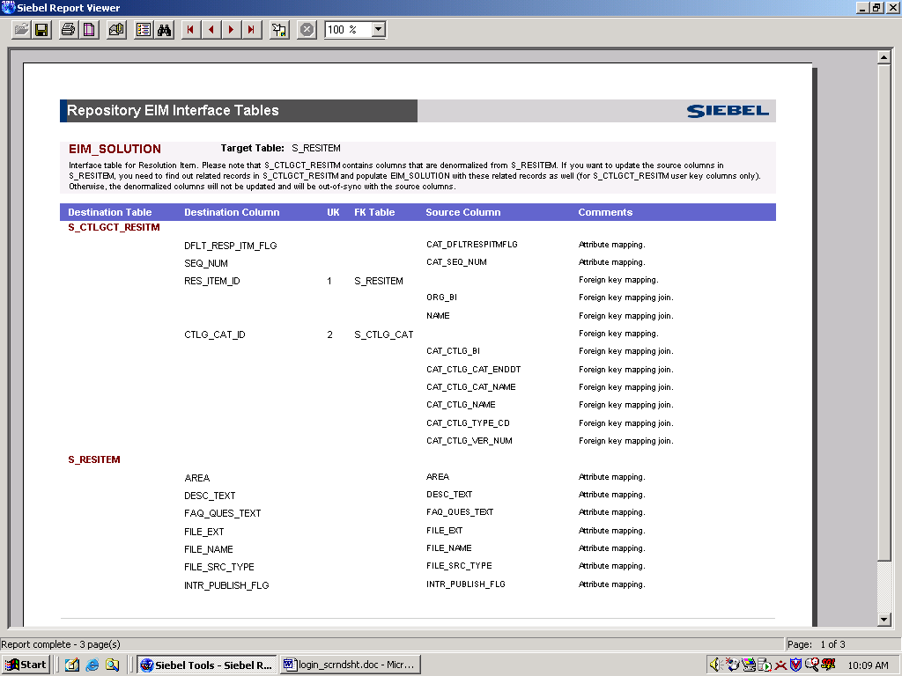.)
  - In the C and D columns of the mapping spreadsheet, record the EIM table and source columns which map to your destination columns.
  - At this point, you would identify any additional required columns for the EIM interface table. (The EIM_SOLUTION table does not have any additional required columns.)
  - Close the report.
- Verify your mappings against the solution.
  - Navigate to C:\Data\Essentials and open solution_mapping_end.xls.
  - Verify that your mappings match the solutions.
  - If they do not, double-check your work.
- Close solution_mapping_start.xls and solution_mapping_end.xls
Lab 34-2 Data Mapping: Products
Goals | To map external product data to Siebel EIM tables for import into Siebel base tables.
Scenario | You have been given a file of legacy product data that you need to import into the Siebel database. You need to construct a data mapping worksheet that identifies how the external source data maps to the EIM table and to the base table.
Time | 30 – 45 minutes
Instructions:
In this lab you will do more work on your own. The instructions are less explicit.
- The legacy team has given you an input file containing product data that you must import into the Siebel database. Navigate to C:\Data\Essentials and open product.txt.
- In the file, a vertical line (|) is used as a delimiter between attributes. It contains seven records with the following three attributes per record:
Attribute
Product Number
Product Name
Unit
- Close product.txt.
- To map the data to Siebel base tables, you decide to work backwards from the UI and Siebel Tools to determine which fields and columns are behind the applet.
  - In Siebel Call Center, find an applet that contains the data you need to import. (Hint: Navigate to the Products screen.) What business component is used for the applets?
  - What is the name of the form applet?
  - In Siebel Tools, find the base table for the form applet you found in the UI. What is the base table?
  - Which three fields look like target fields for the source data? (Hint: Inspect the applet using the Edit Web Layout view.)
Attribute | Field
Product Number
Product Name
Unit
  - Which three columns in the base table map to the three fields you identified in the previous step? (Hint: Inspect the business component using the details view.)
Attribute | Field | Column
Product Number | Part #
Product Name | Name
Unit | Unit of Measure
- A spreadsheet has been started to document the mappings. You need to complete the spreadsheet by filling in rows 1 through 18.
  - Navigate to C:\Data\Essentials and open product_mapping_start.xls.
  - Enter the information you have discovered so far into columns E and F.
(Note: Keep the spreadsheet open so that you can add to it as you proceed.)
- Use Siebel Tools to determine the required columns for the S_PROD_INT table, and the default value for each.
  - In Tools, select the Types tab.
  - Select Table : S_PROD_INT | Column.
  - Execute a query where:
Required = TRUE
Type <> System
Note: You may need to reset the columns default to see the columns needed to execute the query.
  - Add the required columns to the mapping spreadsheet in columns E and F.
  - For the required columns for which you have values, record the default value listed in Siebel Tools on your spreadsheet in column G. (Hint: Remember that the BU_ID columns on the base tables must be populated with the organization name, not the row ID.)
  - Now that you have identified the base (target) table and columns, you need to find candidate EIM tables. What are the candidate parent interface tables? (Hint: In Siebel Tools, select the Flat tab and then select the EIM Table Mapping object and execute a query.)
  - What is the best candidate EIM table and why?
- Now that you have identified the EIM table, you will generate the EIM Interface Tables report. Use this report to determine the column mappings, that is, which EIM columns you need to load to populate your target base table columns.
  - In the C and D columns of the mapping spreadsheet, record the EIM table and source columns which map to your destination columns.
  - At this point, you would identify any additional required columns for the EIM interface table. (The EIM_PROD_INT table does not have any additional required columns.)
  - The interface table, EIM_PROD_INT, maps to four tables; S_PROD_INT and the intersection table, S_PROD_INT_BU, the S_PRI_LST_ITEM and the S_CTLG_CAT_PROD. The intersection table stores the organization associated with a product and its required fields must be populated as well. Inspect the Required column of the intersection table, S_PROD_INT_BU. Add the required columns to the mapping spreadsheet in columns C and D. (Hint: query for Required = TRUE and Type = <>System AND <> Denormalized. You do not need to include the PROD_INT_ID column.)
  - Close the report.
- Verify your mappings against the solution.
  - Navigate to C:\Data\Essentials and open product_mapping_end.xls.
  - Verify that your mappings match the solutions.
  - If they do not, double-check your work or ask your instructor for assistance.
Note: You will use the mappings in a later lab.
- Close product_mapping_start.xls and product_mapping_end.xls.

